Diode Rectifier Lab
Seth Ricks
ECEN 350
Brother Swenson

ECEN 350 – Diode Rectifier Lab (60 points)
(jas, Diode Rectifier Lab.docx, 2/21/2025)

There are both simulation and hardware portions to this lab, and you can work in pairs if desired on the hardware portion, with no three person teams allowed. Each class member is to submit an electronic version of a lab report for credit for this lab. The goal of your lab report is to provide sufficient documentation so that the lab can be repeated if necessary. For your lab report, add a cover page, your results, along with your answers to the Discussion and Conclusions questions to this instruction document. Your cover page is to include class, lab title, author and lab partner. If you worked in a pair, you can share all measured data with your lab partner. However, any simulations along with your Discussion and Conclusions section is to be uniquely yours and not a copy of your lab partners. A grading rubric for this lab is included at the end of this document. The rubric does not need to be included in your lab report.

Purpose: To better understand transformers along with commonly used diode rectification circuitry utilizing silicon pn junction diodes.

Parts and Equipment:
2 – 1N4007 Diodes
1 - 4.7 kΩ Resistor
1 - 10 µF 50 V capacitor (Aluminum Electrolytic).
1 - 120 V rms to 28 V rms Step-Down Transformer.
1 - VirtualBench Measurement System and Computer
1 - Breadboard.
VirtualBench Oscilloscope:

The VirtualBench Oscilloscope User Interface Screen with Channel 1 (red) connected to a 1 kHz sine wave with 5 V peak-to-peak output amplitude is illustrated in Figure 1 below. Several automatic waveform measurements are available for the oscilloscope, controlled by means of the Waveform Measurement Icon illustrated below in Figure 1. Two waveform cursors are also available, controlled by the Waveform Cursor Icon, illustrated below in Figure 1.
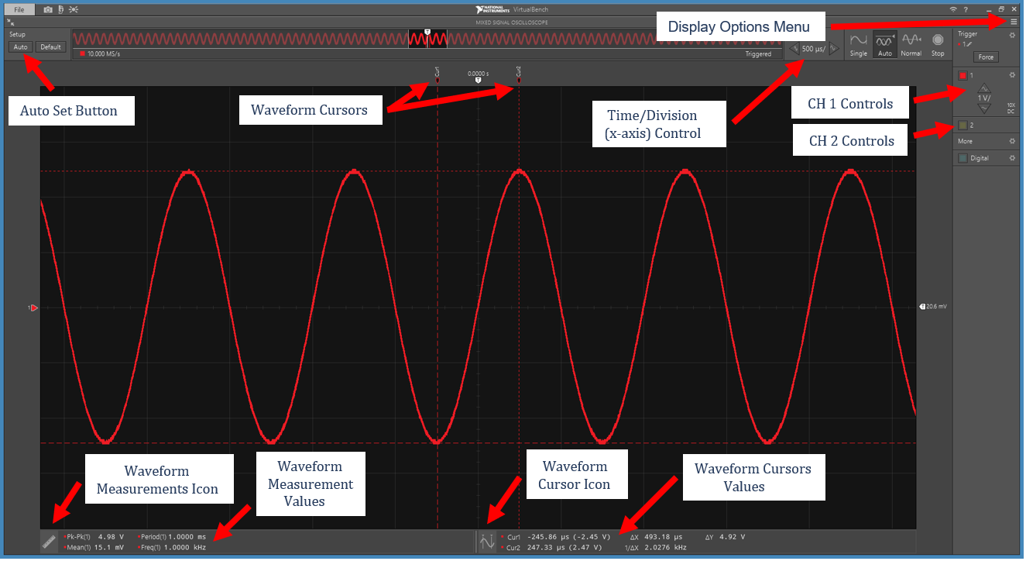
Figure 1: VirtualBench Oscilloscope User Interface Pane Example.

In its simplest form a waveform trigger is a voltage level that provides a reference point for the waveform display. The VirtualBench oscilloscope acquires a sizeable portion of waveform voltage versus time data, then displays the results utilizing a waveform reference point determined by the waveform trigger. This acquisition and display process is repeated over and over, resulting in periodic waveforms appearing stationary when properly triggered. So oscilloscope waveform triggering provides for periodic (repeating) waveforms to look stationary, which is useful for waveform viewing and analysis. Periodic signals with non-negligible random voltage variations (noise) often appear to jitter back and forth on an oscilloscope screen, because the noise causes the trigger reference point to occur at slightly different portions of the waveform each time the waveform is displayed. A Noise Reject triggering Hysteresis option, available in the Trigger Settings pane, helps minimize waveform jitter on noisy signals by noise filtering. Oscilloscopes provide voltage triggering on either rising (increasing) or falling (decreasing) waveform voltages, referred to as Rising or Falling edge triggering.

The VirtualBench oscilloscope offers Auto, Normal and Single triggering modes, along with a Stop mode that stops waveform triggering to freeze the current waveform on the screen. In the Normal trigger mode, the oscilloscope refreshes a displayed waveform after a valid trigger occurs. If a valid trigger never occurs, usually because the trigger level is incorrectly adjusted for a given waveform, then the waveform never refreshes, making it difficult to find the waveform being measured to correctly adjust the trigger. Auto trigger comes to the rescue in these circumstances. In Auto trigger mode, the oscilloscope waits only so long for a valid waveform trigger, then automatically triggers and displays the captured waveform if the predetermined wait time expires before receiving a valid trigger. This helps in hunting for waveforms by providing some user feedback regarding the waveform to be measured. The Auto trigger mode is the default triggering mode for the VirtualBench oscilloscopes. The Auto button illustrated in the upper left-hand corner of the screen in Figure 1, sets the oscilloscope triggering to Auto and also provides for automatic adjustment of the amplitude and time scales in order to better view the waveform.

Single triggering is useful for capturing and then freezing on the screen a one-time event. If you try to view a one-time event using Auto triggering, the oscilloscope will display the event upon receiving a valid trigger, but then refresh the display with a new waveform upon the next trigger. So, each of the three VirtualBench triggering modes have their place in waveform measurements, as does the Stop triggering mode when one does not want the currently displayed waveform to be replaced by a new waveform capture.

Step-Down Transformer:

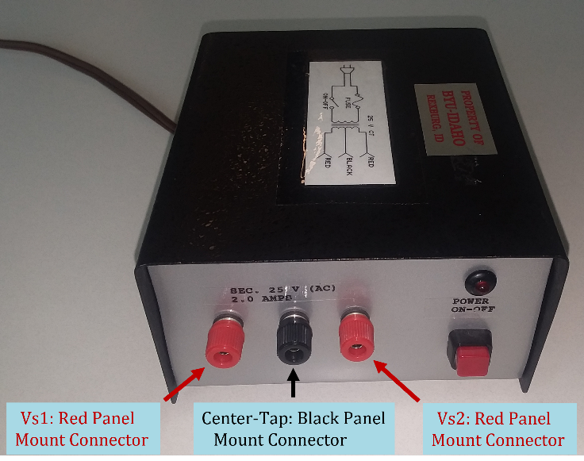
The standard US AC power is 120 V rms at 60 Hz, which translates to (120 V)$\sqrt{2}$ = 170 V peak. This AC voltage is typically stepped down to safer voltages by means of a step-down transformer prior to rectification. A step-down transformer as shown in Figure 2, is to be used for this lab. This center-tapped transformer plugs into the 120 V ac rms in the wall and steps the voltage down to approximately 14 V ac rms (≈ 21 V peak), between the black center tap terminal and either of the red output terminals. The corresponding voltage between the two red output terminals is then approximately 28 V ac rms (≈ 42 V peak).

Figure 2: Center-Tapped Transformer to Use in the Diode Rectifier Lab.

A schematic of the center-tapped transformer is illustrated below in Figure 3.

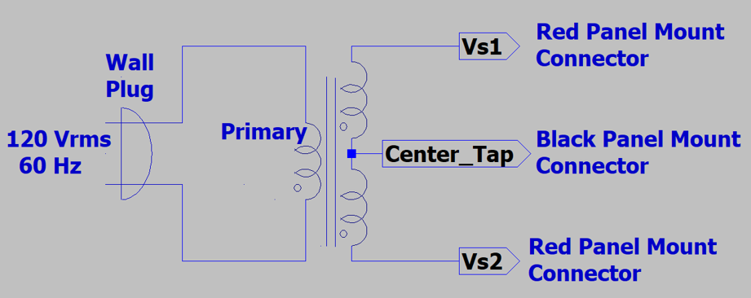
Figure 3: Center-Tapped Step-Down Transformer Schematic.

Procedure:

Part 1 – Center-Tapped Transformer

- Connect the oscilloscope probe with the red marking bands to Channel 1 (CH 1) and the oscilloscope probe with the yellow marking bands to Channel 2 (CH 2) on the VirtualBench CH 1 and CH 2 oscilloscope BNC connectors. Make sure the slide switches at the probe tip end of the oscilloscope probes are set to 10X versus 1X.
- Start up the VirtualBench interface software and for the CH 1 and CH2 settings make sure that both are set for DC coupling and 10X probe attenuation.
- Connect the CH 1 and CH 2 oscilloscope probes to the two red output connectors of the center tapped transformer, with both probe ground clips connected to the black center-tapped connector. It doesn’t matter which probe is connected to which red connector.
Warning: The oscilloscope probe ground clips are connected to earth ground through the oscilloscope AC power cord, meaning that connecting the alligator ground clip to a circuit node shorts that node to earth ground.
- Turn on the transformer and use the Auto Set button in the VirtualBench user interface to display the two waveforms, which should look like the screen capture illustrated in Figure 4 below.
- Enable the Mean, RMS, Peak-to-peak and High VirtualBench measurement functions for both CH 1 and CH 2 measurements, with the High measurement corresponds to the peak voltage value.
- After the measured values are properly displayed, select Stop, to stop the acquisitions, and then record the measured Mean, Peak-to-peak, RMS, and High values for both V_{s1} and V_{s2} in Table 1 below. (8 points.)
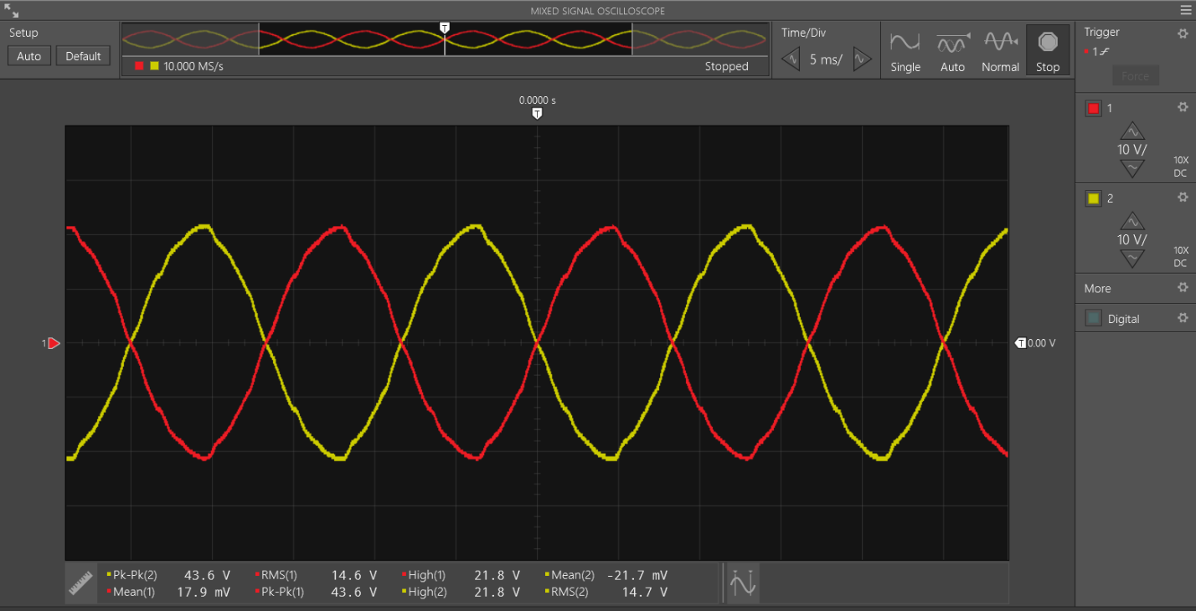
Figure 4: Output Waveforms from the Center-Tapped Step-Down Transformer Schematic.

Table 1: Measured Center-Tapped Transformer Values
V_{s1_mean} | V_{s1_rms} | V_{s1_pk-pk} | V_{s1_pk} | V_{s2_mean} | V_{s2_rms} | V_{s2_pk-pk} | V_{s2_pk}
17.9 mV | 14.6 V | 43.6 V | 21.8 V | -21.7 mV | 14.7 V | 43.6 V | 21.8 V

Part 2 – Hardware Full-Wave Rectifier

- With the transformer turned off, connect up a full-wave center tapped transformer rectifier as shown in Figure 5 below. Be careful to connect the polarized capacitor C1 with the proper polarity to prevent this capacitor from exploding! On the physical capacitor the lead adjacent to a negative polarity stripe on the body of the part indicates the negative lead, which corresponds to the curved plate on the schematic symbol.

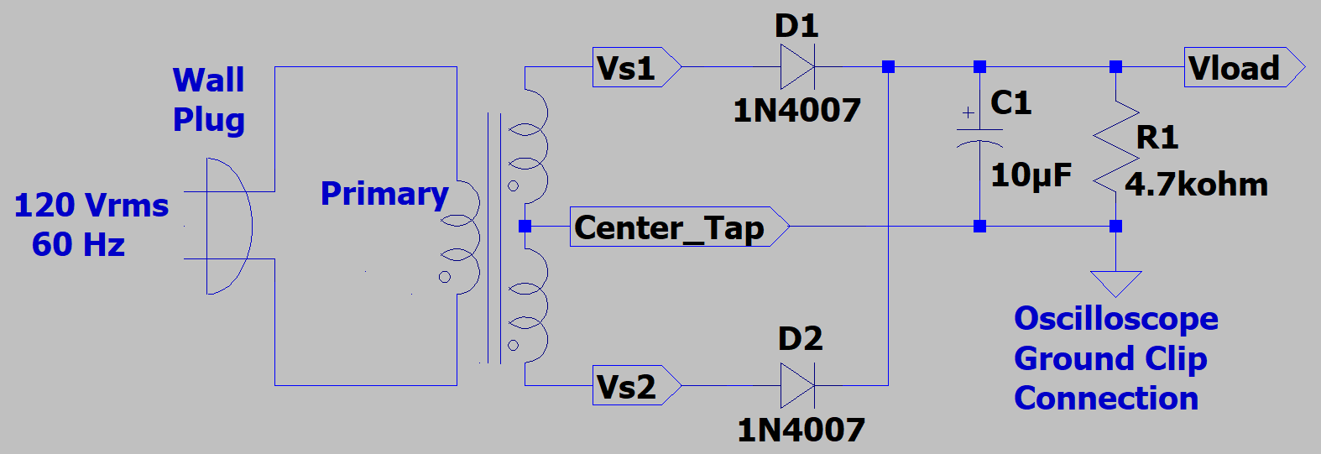
Figure 5: Full-Wave Diode Rectifier Circuit Using a Center-Tapped Transformer.

- Connect the CH 1 oscilloscope probe to the anode (+) side of either diode D1 or D2, and the CH 2 oscilloscope probe to V_{load}, with both ground clips connected to ground. Warning: The oscilloscope probe ground clips are connected to earth ground through the oscilloscope AC power cord, meaning that connecting the alligator ground clip to a circuit node shorts that node to earth ground.
- Adjust the time per division setting near the upper right-hand corner to 5 mS per division.
- Since the output of the transformer is somewhat noisy, averaging 64 measurements together results in much cleaner results. This is to be accomplished by clicking on the three horizontal lines located just above the settings gear of the Trigger menu near the upper left-hand corner of the oscilloscope screen.
- Measurement averaging on the VirtualBench oscilloscope can be invoked by means of a Display Options menu located in the upper right-hand corner of the Oscilloscope Screen, illustrated in Figure 1. Select Acquisition 64 averaged to reduce random measurement noise.
- Make sure that the Mean, RMS, Peak-to-peak and High VirtualBench measurement functions for both CH 1 and CH 2 measurements are still enabled.
- After double checking your circuit for proper capacitor polarity, etc., turn on the transformer, being ready to turn it off if something is amiss with your connections.
- If the powered circuit appears to be connected properly, then you should get waveforms that look like the screen capture illustrated in Figure 6 below after allowing time for the 64 averages to complete.
- Add both waveform cursors to the V_{load} waveform, with Type set to Track. Adjust the cursors along the V_{load} waveform such that one cursor is located at a waveform peak, while the other cursor is located at a waveform valley, as illustrated in Figure 6 below.
- After the measured values are properly settled and displayed, perform a screen capture of the resulting waveforms and measured values. Then replace the screen capture in Figure 6 below with your version, leaving in the figure number and caption. (Note: The peak-to-peak ripple voltage should be < 5 V for a properly functioning circuit. Possible causes for ripple voltages larger than 5 V in the Figure 5 rectifier circuit include R1 noticeably less than 4.7 kΩ, C1 noticeably less than 10 μF, and excessive wire length from the oscilloscope ground clip to the actual circuit ground.) (12 Points.)
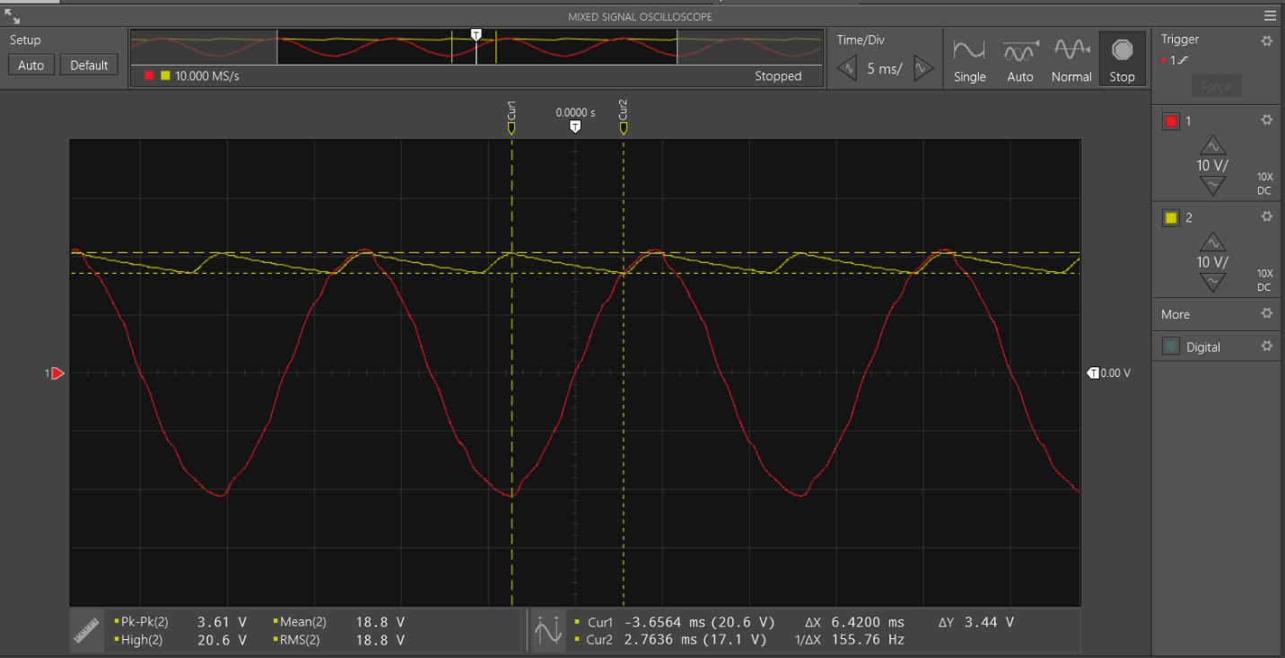
Figure 6: Input and Output Waveforms for the Full-Wave Rectifier Circuit.

- From your VirtualBench measured results, record below in Table 2 the Mean value of the V_{load} as V_{load_meas_avg}, RMS value of V_{load} as V_{load_meas_rms} and cursor ΔY value of the V_{load} waveform as V_{R_meas} for measured ripple voltage. Be sure to include units for your Table 2 values. (6 points.)

Table 2: Measured and Simulated Full-Wave Rectifier Values
V_{load_meas_avg} | V_{load_meas_rms} | V_{R_meas} | V_{load_sim_avg} | V_{load_sim_rms} | V_{R_sim}
18.8 V | 18.8 V | 3.44 V | 19.311 V | 19.311 V | 2.72V

Part 3 – LTspice Full-Wave Rectifier

- Connect up the Full-Wave Rectifier utilizing a center-tapped transformer as shown below in Figure 8. The center-tapped transformer is to be included by placing three separate inductors, with inductance values given in Figure 8. On the Edit pull-down menu in the upper left-hand corner of the LTspice window, choose .op Spice Directive, which opens an edit pane in which to add the following inductor coupling informatioxn: K L1 L2 L3 1, which couples together inductors L1, L2 and L3, forming a transformer. Make sure your polarity dots on the coupled inductors are as shown in the figure for proper phasing. A step-down ratio of 8 is used in this lab to step-down from the 170 V peak to approximately 21 V peak. The step-down ratio in an LTspice transformer constructed from coupled inductors is controlled by the inductance ratios between the primary and secondary.
- For the 1N4007, first place a standard diode from the main LTspice library. Then change the diode type from the generic LTspice silicon pn junction diode to a 1N4007 diode by hovering the hand symbol over the diode and right clicking to open the diode parameter pane, which includes a Pick New Diode button. The Pick New Diode button opens a Select Diode pane with many available diode models, including the 1N4007. Sorting the list by clicking on Part No. will position the 1N4007 diode model either near the top or bottom of the list. Click on the 1N4007 Part No. and then click OK to configure the diode symbol on the schematic to use the 1N4007 diode simulation model. The diode type can also be changed simply by editing the value from D to 1N4007 on the schematic.
- For practical rectifier circuits the output voltage ripple needs to be reduced from the rectified waveform illustrated in Figure 7, which is accomplished by the addition of filter capacitor, i.e., C_{f} in Figure 8 below. Large value polarized electrolytic capacitors are often used for filter capacitors in rectifier circuits. The polcap in the main LTspice component library provides a polarized capacitor symbol.
- In the Edit pull-down menu, add your name to your schematic as follows: Edit Aa Text.
- When completed with your schematic, replace the schematic shown in Figure 8 below with your version, including your name. (12 points.)
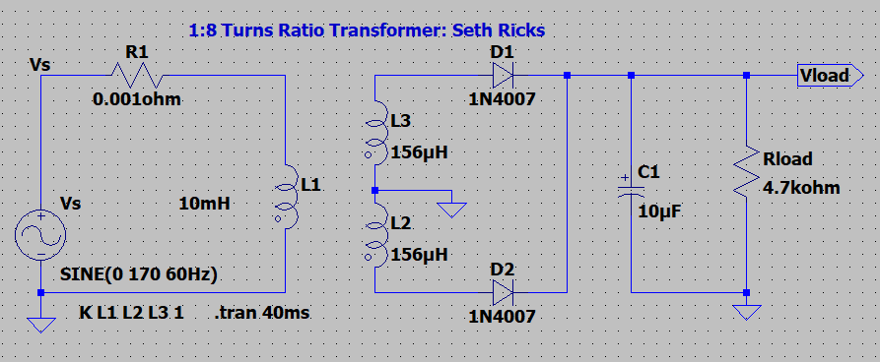
Figure 8. Full-Wave Rectifier Using A Center-Tapped Transformer.

- After running the transient analysis, add a 2nd plot pane by means of Plot Settings → Add Plot Pane. Choose to display V(vload) in the 1st (top) plot pane and V(vs) in the 2nd (bottom) plot pane, as illustrated below in Figure 9. With the two plot panes, click on the appropriate pane before invoking the Plot Settings → Add Trace to get the desired traces associated with the desired plot pane.
- Attach both cursors to V(vload) and then move the cursors to measure the peak-to-peak ripple of the waveform. Then drag the cursor pane onto your plot to document your measured peak-to-peak ripple voltage value as illustrated in the figure below.
- Annotate your plot pane with your name by means of the Plot Settings → Notes and Annotations → Place Text option available by accessing the Plot Settings pulldown menu above the toolbar.
- By means of Plot Settings → Manual Limits, or the ruler icon when hovering the cursor near the horizontal axis, set the horizontal axis limits from 10 ms to 40 ms with 5 ms ticks.
- Hover the mouse over the waveform label at the top of the plot pane, V(vload) and when the hand symbol appears, hold down the Ctrl key while performing a left mouse click to open a Waveform pane indicating Average and RMS values. Move this Waveform pane to a more convenient location on the plot pane. Replace the resulting screen capture below with your version, including the Waveform Pane indicating the average and RMS values of V(vload). (9 Points.)
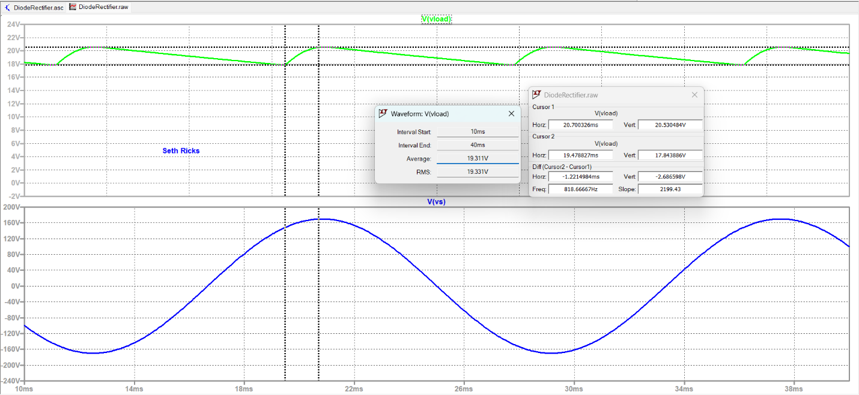
Figure 9. Full-Wave Rectifier Using A Center-Tapped Transformer Simulation Results.

- Record above in Table 2 the Average value of the V_{load} as V_{load_sim_avg}, the RMS value of V_{load} as V_{load_sim_rms} and the ΔY cursor value of the V_{load} waveform as V_{R_sim} for measured ripple voltage. Be sure to include units for your Table 2 values.

Discussion and Conclusions Questions: (For the following questions use your own words along with complete sentences. Points are to be deducted for AI generated answers.)

- In your own words describe the reason for using a relatively large value capacitor in parallel with the output of the diode rectifier circuits used in this lab. (4 Points.)
If we didn’t have the capacitor in parallel with the output of the rectifier circuit, the rectified waveform would have a smaller average voltage. The purpose of the capacitor is to hold charge while the AC input waveform is at 0, switching directions. This flattens out the output waveform and increases the average voltage.

- Based on your oscilloscope observations, what was the frequency of the full-wave rectified output signal relative to the frequency of the input signal prior to rectification? (1 Point.)
The frequency of the full-wave rectified output is double the input signal. This is because for every peak in the input signal, there is a peak in the output signal.

- The following formula is to be used to estimate the peak-to-peak ripple voltage for given load current and filter capacitor C_{f}, and ripple frequency of the rectified waveform $f_{R}$:
$$V_{R}=\frac{I_{load}}{f_{R}C_{f}}.$$

Calculate the expected peak-to-peak ripple voltage of the full-wave rectifier circuit of Figure 5, with I_{load} determined from V_{load_meas_avg} value from Table 2 and the load resistance of Figure 5. (Note that f_{R} is not equal to the standard US 60 Hz AC Power frequency.) (2 Points.)

V_{load_meas_avg} = 18.8 V; R_{L} = 4.7 kΩ; I_{load} = 4.00 mA
$$V_{R}=\frac{I_{load}}{f_{R}C_{f}}=\frac{4.00mA}{60*2 Hz*10μF}=3.33 V$$

Diode Rectifier Lab Grading Rubric: Submit an electronic version of a lab report for credit for this lab. The goal of your lab report is to provide sufficient documentation so that the lab can be repeated if necessary. For your lab report, add a cover page, your results, along with your answers to the Discussion and Conclusions questions to this instruction document. Your cover page is to include class, lab title, author and lab partner. If you worked in a pair, you can share all measured data with your lab partner. However, any simulations along with your Discussion and Conclusions section is to be uniquely yours and not a copy of your lab partners. The rubric below does not need to be included in your lab report.
Lab Report Item | Points
Cover Page | 2
Part 1 – Center-Tapped Transformer  Reasonable Table 1 Values with Units.  (1 point per entry, -0.25 points for each missing unit.) | 8
Part 2 – Hardware Full-Wave Rectifier  Figure 6: (12 – points total, 1 point for reasonable AC input waveform, 1 point for reasonable rectified DC output waveform, 2 points for proper cursor setup indicating ripple voltage on the output waveform, 8 points for including automatic measurements with 1 point each for automatic measurements of Mean, RMS, Peak-to-peak and High V for each channel.)  Table 2: (6 – points total, 1 point per entry, -0.25 points per entry for missing units. Award full credit for dc and rms voltage values ranging from 17 to 20 V, and voltage ripple V_{R} values ranging from 2.5 to 3.5 V.) | 18
Part 3 – LTspice Full-Wave Rectifier  Figure 8: (12 points total – 1 point for voltage source with SINE(0 170V 60Hz) configuration statement, 1 point for R1, 1 point for Rload, 1 point for C_{f}, 2 points for correct inductor connections along with L1 = 10mH and L2 =L3 = 156µH, 2 points for correct diode connections and D1N4007 type and model statement, 1 point for inductor coupling command K L1 L2 L2 1, 1 point for correct ground connections, 1 point for .tran 40m statement, 1 point for name included on schematic.)  Figure 9: (9 points, 1 point for reasonable V(vload) waveform, 1 point for reasonable V(vs) waveform, 1 point for including 2nd plot pane, 1 point for proper cursor setup indicating ripple voltage on the output waveform, 2 points for including cursor pane on the plot pane, 1 point for Waveform pane included on the plot pane, 1 point for horizontal axis limits of 10 ms to 40 ms, 1 point for including name as annotation.) | 21
Discussion and Conclusions | 7
Grammar and Professionalism | 4
Total | 60

Please give feedback on errors you find in this document.

